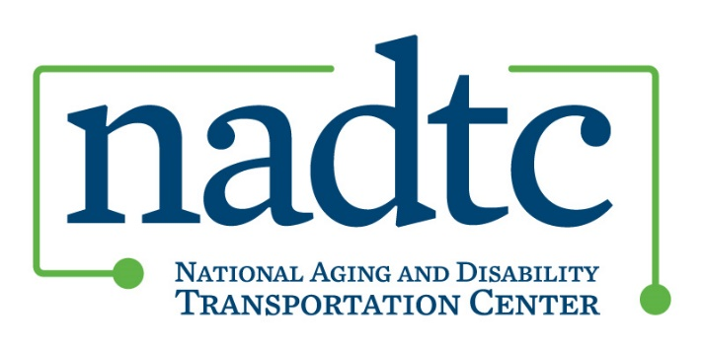

2020 Innovations in Accessible Mobility Grant
UPDATE

The due date for Grant Applications has been extended to 5:00 pm Eastern time on May 1, 2020.

Q: Given the current coronavirus situation, what happens with the timing of this grant if
interpersonal interaction is limited? Will there still be a May start date and November end
date?
As noted above, we are extending the deadline for receiving grant applications to May 1 for now, with an anticipated award date of June 15. We are also making adjustments to other key dates (specified below and on the NADTC website) and will consider additional changes in response to changing conditions. The date for convening a grantee orientation and training meeting in Washington DC will be determined, and applicants are expected to include funds for participating in an in-person meeting in their proposed budgets.

Q: Can you provide the award date?

We now expect to announce the grants by June 15.

Key Dates (revised)
May 1, 2020: Application Due Date
June 15, 2020: Grant award announcement/grantees begin their work
TBD: Grantee orientation and training, Washington, DC
December 15, 2020: End date of grant activity

Would a proposal to develop and implement an innovation in response to the coronavirus be considered for funding?
Yes, such a project would be considered (we have also noted this change on the NADTC website). Obviously, this situation is having a significant impact on community services, reducing the demand for transportation and in some cases, creating transportation gaps due to the suspension of services. There are opportunities to develop creative responses to the current crisis and we want to encourage communities to propose innovative projects that respond to emergency declarations and specific conditions in their communities that are impacting the health and well-being of older adults and people with disabilities. NADTC’s expectation is that funded projects must be sustainable, that is, innovations designed to make lasting changes in the grantee community and its ability to respond to future emergencies, and have the potential to be replicable in other communities across the U.S.

